13.Changing lanes

2020112921 刘欣豪

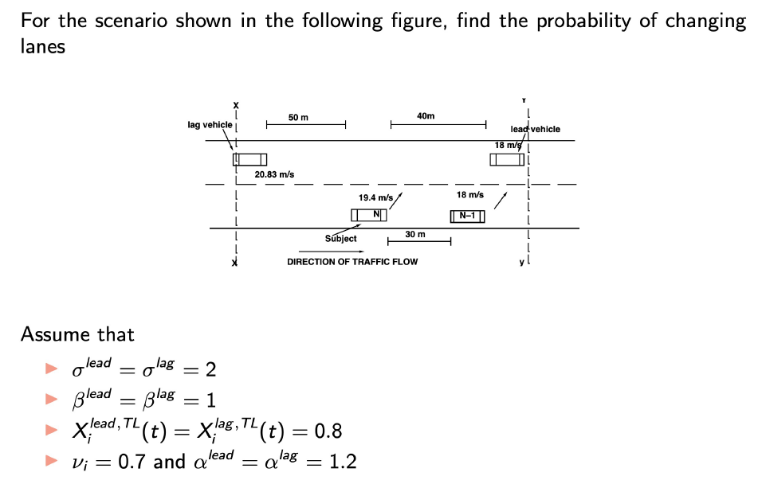

代入：

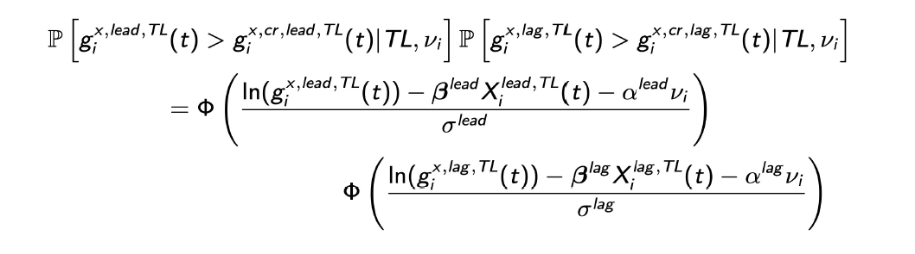





经查表0.8729\*0.8461=0.7386=73.86%